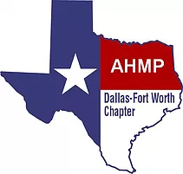
Agenda
June 27th, 2019
American Airlines Headquarters
4255 Amon Carter Blvd.
Fort Worth, TX 75155
(817) 967 – 1069
Contact: Bruce.Campbell@AA.com

EXECUTIVE COMMITTEE OFFICERS:
Q President – Dee Mudzingwa VP/President Elect: Ron Wilkins
Treasurer – Allison King Secretary – Diana Lundelius
Past President – Barry Hallmark Member at Large - Bruce Campbell
Webmaster – Amber Steed

6:15 PM: Arrival and Mingling at American Airlines Headquarters

6:30 PM: Technical Presentation
Tailoring Business Continuity with Crisis Response Software to Produce
Valuable Environmental Management Tools by Asciatu Whiteside

7:15 PM: Chapter Meeting
- Business Meeting Call to Order
- Chapter Outlook
- Chapter Affiliation Agreement
- By-laws Revision
- 2019 Strategic Initiatives
- National Updates/ Conference Delegate Selection
- Service Recognition
- Upcoming Events

